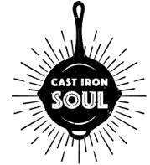
Email: castironsoultx@gmail.com
Phone: (409) 454-0197
**See full menu AND follow us on our socials:
Instagram: @cast_iron_soul_tx
Facebook: CAST IRON SOUL

Cast Iron Soul Menu

Texas Craft Tacos: Smoked chicken or brisket on a flour tortilla with red and/or green salsa. Garnished with cilantro and queso fresco. Chicken tacos come with Mexican white cheese. $5
Quesadillas: Smoked chicken or brisket between two flour tortillas with cheese and red and/or green salsa. Garnished with cilantro and queso fresco. Chicken quesadillas come with grilled onion and poblano. $10
Kid’s Cheese Quesadilla: $4

Drinks:
Water Bottle $1
Sodas/Gatorade $2

Pulled Pork Sliders: Smoked pulled pork with a sweet and spicy barbeque sauce on a Hawaiian slider bun. Includes a small side of jalapeño cole slaw. $5
Street Corn: A cup of corn that has been cooked down with diced onion, jalapeño, and Mexican crema. Garnished with cilantro, queso fresco, and hot Cheetos. $5

**Have questions? Need someone to cater your next party or event? Contact us!
castironsoultx@gmail.com or (409) 454-0197

